**REPORT 2 – GROUP PROJECT**

***Energy Saver using IR Sensor and Fire Alarm***

Submitted towards the professional course

**15Z610 – Embedded Systems Laboratory**

Celciya . K (17z311)

Dhivya . M (17z313)

Nishanth . S (17z332)

Shalini . D (18z475)



**12 March 2020**

***Department of Computer Science and Engineering***

***PSG College of Technology,***

***Coimbatore - 641 004.***

1. **INTRODUCTION**

In the beginning of electrification, switching between electrical devices is done by either connecting or disconnecting them to the power grid. Now-a-days disconnecting a device from its energy source become less popular. And also, there may be a chance to get an electric shock, when the human being is trying to disconnect a device without any precautions. So, switching between electrical device can be made electrically(automatically). This gives an easy way to switch the device (powered ‘on’ or ‘off’) by a remote-control unit or an automated switching circuit based on the number of persons inside in the particular room. So that the electricity consumption is reduced in the absence of persons.

This project presents the workflow to design the Energy Saver using IR sensor to reduce the electricity consumption especially in the class room and give an emergency alarm when fire is detected inside.

1. **PROBLEM STATEMENT**

Consider a class room, where there is a chance of high probability that the students might be fail to switch off the lights due to the carelessness. So, the lot of electricity is wasted until manually switch off the lights. This project provides the system which will be focusing on such an issue. This Energy Saver using PIR sensor is used to switch ‘off’ the lights in the absence of students. When a student enters the classroom, the Infrared energy emitted from the living body is focused by the Fresnel lens segment and the IR sensors were activated and give to the microcontroller which acts as power saving device according to the relay. When motion is detected, it triggers and switch the light ‘on’. If no motion has been detected, the system will switch ‘off; the lights after 10 minutes. The lights will be put on only when the room’s natural light intensity goes below 10.

1. **COMPONENTS REQUIRED**
   * + Arduino UNO
     + Bread board
     + LM35 – Temperature sensor
     + 10k ohm resistor
     + PIR (Passive Infra-Red) Sensor
     + Jumpers
     + SIM800L
     + LEDs (Light Emitting Diode)
     + Photoresistor
2. **SCHEMATIC DIAGRAM**

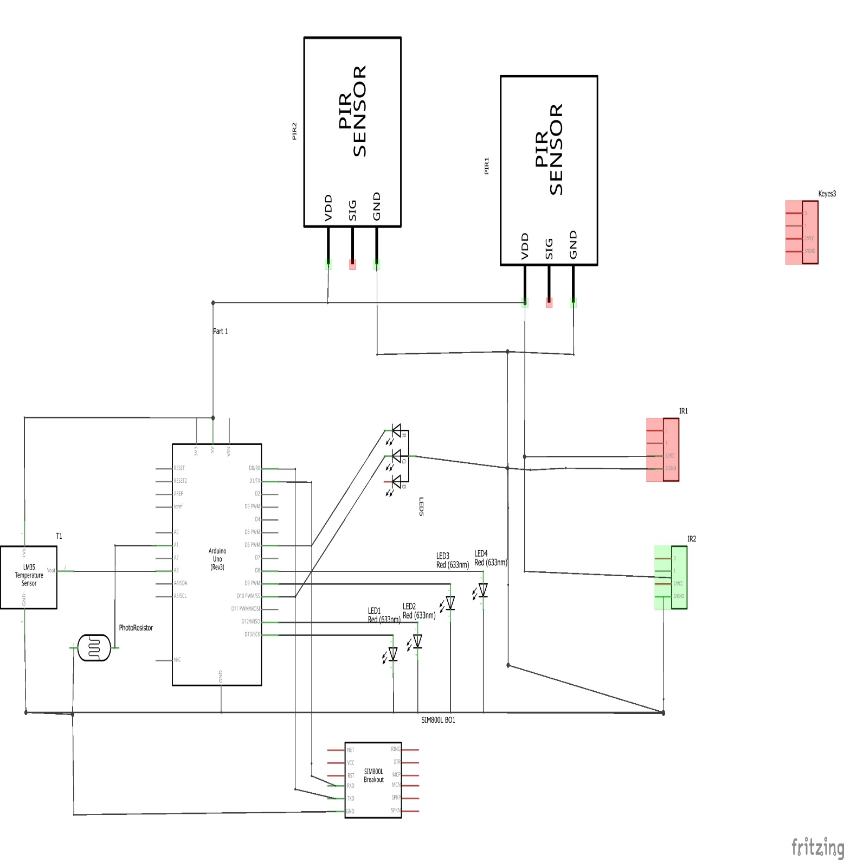

1. **CODE**

**Light Control**

int count = 0;

void setup() {

// put your setup code here, to run once:

Serial.begin(9600);

pinMode(0,OUTPUT);

pinMode(1,OUTPUT);

pinMode(2,INPUT);

pinMode(3,INPUT);

pinMode(4,INPUT);

pinMode(5,INPUT);

pinMode(7,OUTPUT);

pinMode(8,OUTPUT);

pinMode(9,OUTPUT);

pinMode(12,OUTPUT);

pinMode(13,OUTPUT);

pinMode(A1,INPUT);

pinMode(A3,OUTPUT);

pinMode(A5,OUTPUT);

}

void loop() {

// put your main code here, to run repeatedly:

int n = digitalRead(2);

int ls = analogRead(A1);

Serial.print("IR : ");

Serial.println(n);

if(n==0){

digitalWrite(8,HIGH);

count=1;

// delay(1000);

// digitalWrite(3,LOW);

}

if(count == 0){

digitalWrite(8,LOW);

}

//digitalWrite(8,HIGH);

int s1 = digitalRead(3);

int s2 = digitalRead(4);

int s3 = digitalRead(5);

Serial.print("S1 : ");

Serial.println(s1);

Serial.print("S2 : ");

Serial.println(s2);

Serial.print("S3 : ");

Serial.println(s3);

Serial.print("LS : ");

Serial.println(ls);

if(ls>5){

digitalWrite(11,LOW);

digitalWrite(12,LOW);

digitalWrite(13,LOW);

}

if(s3==1){

digitalWrite(9,HIGH);

digitalWrite(12,HIGH);

digitalWrite(13,HIGH);

}

else if(s2==0){

digitalWrite(9,LOW);

digitalWrite(12,HIGH);

digitalWrite(13,LOW);

}

else if(s1==1){

digitalWrite(9,HIGH);

digitalWrite(12,LOW);

digitalWrite(13,LOW);

}

else{

digitalWrite(9,LOW);

digitalWrite(12,LOW);

digitalWrite(13,LOW);

}

int t = analogRead(A3);

Serial.print(" T : ");

Serial.println(t);

if(t>37){

if(t<=30){

digitalWrite(6,HIGH);

}

else{

digitalWrite(10,HIGH);

}

tone(7,500);

delay(1000);

noTone(7);

//digitalWrite(8,LOW);

digitalWrite(9,LOW);

digitalWrite(12,LOW);

digitalWrite(13,LOW);

delay(2000);

// digitalWrite(0,LOW);

// digitalWrite(1,LOW);

}

delay(1000);

}

**SMS alert using GSM**

#include <SoftwareSerial.h>

//#include<LiquidCrystal.h>

//LiquidCrystal lcd(12, 11, 5, 4, 3, 2);

SoftwareSerial sim(9, 10);

int sense=A1;

float temp_read,alert_val,shut_val;

int sms=0,fire_val;

void setup(){

pinMode(sense,INPUT);

sim.begin(9600);

Serial.begin(9600);

// lcd.begin(16,2);

delay(500);

}

void loop(){

isFire();

shutDown();

}

void isFire(){

//lcd.setCursor(0,0);

//lcd.print("Fire Scan - ON");

alert_val=TempReader();

if(alert_val>45){

giveAlert(); // Function to send SMS Alerts

}

}

float TempReader(){

temp_read=analogRead(sense); // To read sensor output (Vout of LM35)

temp_read=temp_read*5; // To convert sensor output to temperature

temp_read=temp_read/10; // To add the decimal point

return temp_read; // Returns temperature value in celsius

}

void giveAlert(){

while(sms<3){ // Number of SMS to be sent

SendSMS(); // Function to send AT Commands to GSM module

}

fire_val=1;

//lcd.setCursor(0,1);

//lcd.print("Fire Alert! SMS Sent!");

}

void shutDown(){

if(fire_val==1){

shut_val=TempReader();

if(shut_val<28){

//lcd.setCursor(0,1);

//lcd.print("Fire Shut! SAFE NOW");

sms=0;

fire_val=0;

}

}

}

void SendSMS(){

sim.println("AT+CMGF=1"); // SMS in Text Mode

delay(2000);

sim.println("AT+CMGS=\"+917339669190\"\r"); // Mobile number for receiving SMS

delay(2000);

sim.println("Fire in NEW ROOM!"); // SMS content

delay(200);

sim.println((char)26); // stopping character

delay(5000);

sim.println("AT+CMGS=\"+919003643538\"\r"); // Mobile number for receiving SMS

delay(2000);

sim.println("Fire in NEW ROOM!"); // SMS content

delay(200);

sim.println((char)26); // stopping character

delay(5000);

sms++;

}

1. **CHALLENGES FACED**

IR Sensor: In the outer environment, the light intensity may be very high. The value of IR sensor will be 1(incorrect). So, it is difficult to obtain correct value.

GSM Connection: Problem faced during acquiring network signal in GSM.

1. **CONTRIBUTION OF TEAM MEMBERS**

Celciya – Documentation

Dhivya - SMS alert using GSM

Nishanth – Automatic light control using IR sensor implementation

Shalini - Design methodology

1. **REFERENCES**
2. <https://www.electronicshub.org/ir-sensor/>
3. <https://www.banggood.in/buy/pior-led-lampmotion-sensor-led-bulb.html>
4. <https://www.electronics-tutorials.ws/io/io_4.html>
5. <https://www.dilsonenterprises.net/simcom-gsm-gprs-module.html>
6. <https://www.sciencedirect.com/topics/materials-science/thermal-sensor>